|  |
| --- |
| AIM Duration: 2 hours |
| * Create magazine using columns page boarders, header footer |

|  |
| --- |
| LEARNING OUTCOME |
| Able to create document spread sheet and make presentation using open office. |

|  |
| --- |
| REQUIREMENT |

|  |
| --- |
| List of Hardware/Software requirements:   * Computer Desktop/Laptop * Windows Operating system * Open Office |

PROCESDURE

Step 1: Select from the main menu Insert > Header > [Page Style]. The submenu contains as many entries as page styles used in your document. In addition, the submenu includes the entry All, which activates headers on all the pages of the document.

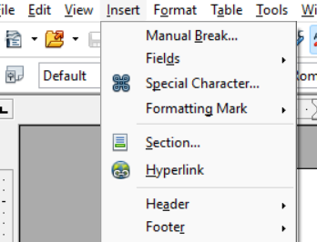

Step 2: Similarly, to insert a footer, choose Insert > Footer.

Step 3: Depending on which option you choose; an area will appear at the top or bottom of the page. In this area you can enter text and graphics that will appear on every page.

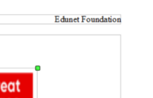

Step 4: Items such as document titles, chapter titles, and page numbers, which often go into headers and footers, are best added as fields. That way, if something changes, the headers and footers are all updated automatically.

